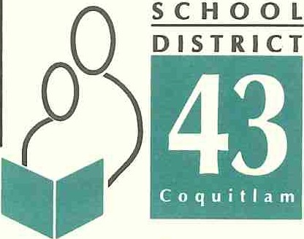
550 Poirier Street, Coquitlam, BC Canada V3J 6A7 • Phone: 604-939-9201 • Fax: 604-937-6758

Learning for a Lifetime

A Message to Pare.-nts: Halloween Appropriateness
.

Halloween across all schools in SD43 is a fun and festive day which brings the school community together. Typically the time around Halloween is incident-free and very respectful.

From time to time, a few students "in character" push the bounds of what is socially acceptable, or what is appropriate behavior in schools, sometimes at the expense of others. With that in mind, and to ensure that every student and adult in our community enjoys the time around Halloween, we would like your assistance in reinforcing these guidelines with your children, for student safety and school climate reasons:

• Students in costume should be easily recognizable and/or identify themselves to any staff members when queried.
• By law and School District expectations, the use and possession of firecrackers or fireworks at school is strictly prohibited. This pertains to students before, during or after school, on or offsite.
• Replica weapons (guns, knives, etc.) are inappropriate, as are costumes which are hyper­ sexualized, or costumes which depict elements of sexual exploitation. Please encourage your children to avoid glamorizing sexual exploitation by refusing to allow them to wear Halloween costumes that re-victimize those who have suffered the devastation of this crime.
• Students "in character" are to conduct themselves appropriately. Behaviours which intimidate, harass or humiliate members of the community, or other behaviours which are inappropriate at the expense of others, do not contribute to a fun, festive, and safe environment.

Finally, and with respect to the 'clown phenomenon' that has recently been portrayed in the media, it is important for all of us to recognize that there still exists a level of sensitivity to this situation among some of our students, especially younger students. All individuals need to be mindful and respectful of this, and should regulate their behavior with previously stated guidelines in mind. Acting inappropriately in this context is in extremely poor taste. It is also prudent for all adults to work with our children constructively. We must not feed any anxiety our children may have, but instead help them rationally interpret the behavior of other, bring some perspective, and equip them to deal with situations which make them feel uncomfortable.

With your assistance, I trust we will have a wonderful next few weeks, and our children will continue to love being at school. Thank you for your support.

Please refer to these readily available public websites of our partner agencies for more information:

http://www.coguitlam.ca/public-safety/holiday-seasonal-safety.aspx
http://coquitlam.rcmp-grc.gc.ca/ViewPage.action?siteNodeld=319&1anguageld=l&contentld=39174 www.childrenofthestreet.com
;;:
Patricia Gartland,
Superintendent

Serving the communities of Anmore, Belcarra, Coquitlam, Port Coquitlam and Port Moody

